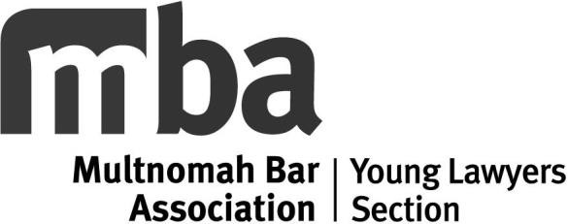 | Estate Planning  Spring 2024 CLE SEMINAR SERIES  A series of seminars on basic litigation issues. Nine hours of practice skills and one hour of ethics OSB MCLE credit will be applied for in total.
Date/Time: A nine-part series with seminars from 12-1 p.m., beginning Thursday, April 18, 2024.
Location: Remote attendance only via Zoom.
Cost: $150 for members (or $30 per individual seminar); non-members $250 (or $45 per individual seminar).

 | Thursday, April 18 | Wills and Trusts 101  Grant Yoakum and Dean Gibbons
 | Thursday, April 25 | Advanced Trust Planning  Grant Burton, Hillsboro Law Group PC
 | Thursday, May 2 | Tax Issues and Estate Planning: Implications of 2026 Act and other Legislative Updates  Heather Kmetz, Sussman Shank LLP
 | Thursday, May 9 | Government Benefits and Estate Planning  Layla McLean, Buckley Law P.C.
 | Thursday, May 16 | Guardianships and Conservatorships  Jessie Minger
 | Thursday, May 23 | Ethics in Estate Planning  David Elkanich, Buchalter Law Firm
 | Thursday, May 30 | Marriage Issues  Abby Wool Landon, Wool Landon LLC
 | Thursday, June 6 | Estate Administration  Amy Bilyeu, Wyse Kadish LLP
 | Thursday, June 13 | Estate and Trust Litigation  Jessica Lancaster, Allegiant Law

Name OSB # Firm Billing Address  Receipt Email | COMPLETE SERIES REGISTRATION  - $150 for MBA members  - $250 for non-members  OR  Select individual classes above and enter number of seminars below.  (# of seminars) @ $30 ea. (members):  (# of seminars) @ $45 ea. (non-members):  TOTAL: | $  $  $
Register online at www.mbabar.org/cle or return form with payment to Multnomah Bar Association, 620 SW 5th Ave Ste 1220, Portland OR 97204. Sorry, no refunds.
PAYMENT OPTIONS:

Check Visa MasterCard AMEX Card #

Exp. Date Security Code Signature

4115 YLS Winter

